Form 20.1 Notice of Site Visit to Members of the Site Visit Team
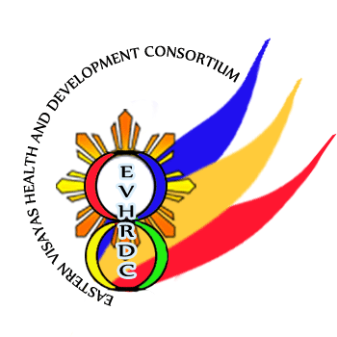

Republic of the Philippines

EASTERN VISAYAS HEALTH RESEARCH AND DEVELOPMENT CONSORTIUM

Gov’t Center, Candahug, Palo, Leyte

<dd/mm/yyyy>

<NAME OF ERC MEMBER>
EVHRDC Member

Re: <STUDY PROTOCOL TITLE> <EVHRDC ERC CODE>

Dear <TITLE OF VISITING TEAM MEMBER> <SURNAME>:

We wish to inform you that the EVHRDC-ERC has appointed you to be a member of the Site Visit Team responsible for verifying compliance of the study site with EVHRDC-ERC approved protocol and related documents, such as, contents of the informed consent form, etc. This site visit is being organized because of: ________. As part of the team, your responsibilities include the following:
- Review the study protocol and the ICF (note: make sure that the site is using the most recent version)
- Review the submitted Form 9.1 Progress Report (note: make sure that the site is using the most recent version)
- Ask the PI or staff to explain the informed consent process
- Ensure security, privacy, and confidentiality of the documents at the study site
- Discuss the findings with the research team
- Solicit feedback from the study site

The details of the Site Visit are as follows:
Study Site
Address
Date | <dd/mm/yyyy>
Time | <hh:mm>

To facilitate the intended site visit, please signify your confirmation by signing in the space provided below, date your signature, and return one copy of this letter to the EVHRDC-ERC Staff Secretary.

Thank you and best regards.

Very truly yours,

Name and Signature

Chair, EVHRDC-ERC

Name and Signature

CONFORME of ERC Member
DATE SIGNED: <dd/mm/yyyy>

