Form 20.2 Notice of Site Visit to Principal Investigator
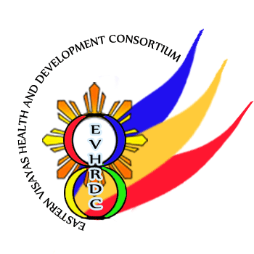

Republic of the Philippines

EASTERN VISAYAS HEALTH RESEARCH AND DEVELOPMENT CONSORTIUM

Gov’t Center, Candahug, Palo, Leyte

<dd/mm/yyyy>

<NAME OF PRINCIPAL INVESTIGATOR>
Principal Investigator

Re: <STUDY PROTOCOL TITLE> <EVHRDC ERC CODE>

Dear <PI>:

We wish to inform you that the EVHRDC-ERC has scheduled a Site Visit for your site beginning on ___________ at ______ and lasting for ___ hours. In addition to yourself, I would appreciate the opportunity to meet the other members of your team during this visit.

During the visit, the team would like to verify the compliance of the study site and to perform the following:
1. Review the study protocol and the ICF (note: make sure that the site is using the most recent version)
2. Review the submitted Form 9.1 Progress Report (note: make sure that the site is using the most recent version)
3. Ask the PI or staff to explain the informed consent process
4. Ensure security, privacy, and confidentiality of the documents at the study site
5. Discuss the findings with the research team
6. Solicit feedback from the study site

To facilitate the intended site visit, please signify your confirmation by signing in the space provided below, date your signature, and return one copy of this letter to the EVHRDC-ERC Staff Secretary. If you have any questions or concerns about anything outlined in this notification or any study related issues, you may visit the staff secretary at the EVHRDC-ERC Office, email us at evhealthresearch2020@gmail.com, or call telephone number (053) 888-4203 for assistance.

Very truly yours,
Name and Signature
Chair, EVHRDC-ERC
Name and Signature

CONFORME of Principal Investigator
DATE SIGNED: <dd/mm/yyyy>

